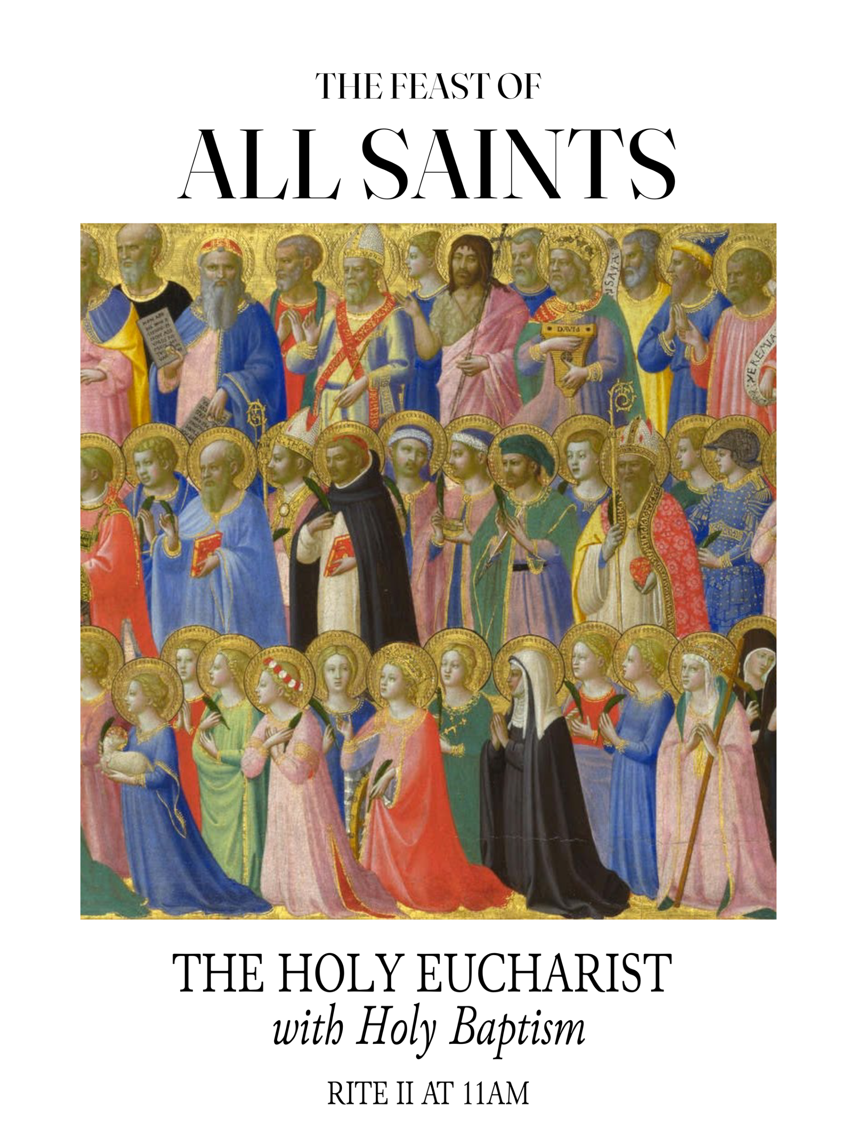

Bishop
The Right Reverend Jacob W. Owensby, Ph.D.

Rector
The Reverend Father Matthew Ainsley

Chaplain and Associate for Youth
The Reverend Jacob Schlossberg

Deacon
The Reverend Honey Becker

The Holy Eucharist: Rite II

ENTRANCE HYMN By all your saints still striving Hymnal 232

OPENING ACCLAMATION

The people standing, the Celebrant says
Blessed be God: Father, Son, and Holy Spirit.
People And blessed be his kingdom, now and for ever. Amen.

The Celebrant then continues
There is one Body and one Spirit;
People There is one hope in God's call to us;
Celebrant One Lord, one Faith, one Baptism;
People One God and Father of all.

The Gloria Glory to God sung Hymnal S-280
The “S” indicates Service Music found in the front section of the Hymnal
Glory to God in the highest, and peace to his people on earth. Lord God, heavenly King, almighty God and Father, we worship you, we give you thanks, we praise you for your glory.

Lord Jesus Christ, only Son of the Father, Lord God, Lamb of God, you take away the sin of the world: have mercy on us: you are seated at the right hand of the Father: receive our prayer.

For you alone are the Holy One, you alone are the Lord, you alone are the MostHigh, Jesus Christ, with the Holy Spirit, in the glory of God the Father. Amen.

The Collect of the Day the People remain standing
Celebrant: The Lord be with you. People: And also with you.
Almighty God, you have knit together your elect in one communion and fellowship in the mystical body of your Son Christ our Lord: Give us grace so to follow your blessed saints in all virtuous and godly living, that we may come to those ineffable joys that you have prepared for those who truly love you; through Jesus Christ our Lord, who with you and the Holy Spirit lives and reigns, one God, in glory everlasting. Amen.

Children dismiss for lessons and activities.

Old Testament Revelation 7:9-17
After this I, John, looked, and there was a great multitude that no one could count, from every nation, from all tribes and peoples and languages, standing before the throne and before the Lamb, robed in white, with palm branches in their hands. They cried out in a loud voice, saying, "Salvation belongs to our God who is seated on the throne, and to the Lamb!" And all the angels stood around the throne and around the elders and the four living creatures, and they fell on their faces before the throne and worshiped God, singing, "Amen! Blessing and glory and wisdom and thanksgiving and honor and power and might be to our God forever and ever! Amen. Then one of the elders addressed me, saying, "Who are these, robed in white, and where have they come from?" I said to him, "Sir, you are the one that knows." Then he said to me, "These are they who have come out of the great ordeal; they have washed their robes and made them white in the blood of the Lamb. "For this reason they are before the throne of God, and worship him day and night within his temple, and the one who is seated on the throne will shelter them. They will hunger no more, and thirst no more; the sun will not strike them, nor any scorching heat; for the Lamb at the center of the throne will be their shepherd, and he will guide them to springs of the water of life, and God will wipe away every tear from their eyes."
Reader: The Word of the Lord. All: Thanks be to God.
PSALM 34:1-10, 22 Sung by the choir, the People remaining seated.

I will bless the Lord at all times; *
his praise shall ever be in my mouth.

I will glory in the Lord; *
let the humble hear and rejoice.

Proclaim with me the greatness of the Lord; *
let us exalt his Name together.

I sought the Lord, and he answered me *
and delivered me out of all my terror.

Look upon him and be radiant, *
and let not your faces be ashamed.

I called in my affliction and the Lord heard me *
and saved me from all my troubles.

The angel of the Lord encompasses those who fear him, *
and he will deliver them.

Taste and see that the Lord is good; *
happy are they who trust in him!

Fear the Lord, you that are his saints, *
for those who fear him lack nothing.

The young lions lack and suffer hunger, *
but those who seek the Lord lack nothing that is good.

The Lord ransoms the life of his servants, *
and none will be punished who trust in him.

The Epistle 1 John 3:1-3

See what love the Father has given us, that we should be called children of God; and that is what we are. The reason the world does not know us is that it did not know him. Beloved, we are God's children now; what we will be has not yet been revealed. What we do know is this: when he is revealed, we will be like him, for we will see him as he is. And all who have this hope in him purify themselves, just as he is pure.
Reader: The Word of the Lord. All: Thanks be to God.

Sequence Hymn Blest are the pure in heart Hymn 656

The Gospel Matthew 5:1-12
Deacon: The Holy Gospel of our Lord Jesus Christ according to Matthew All: Glory to you, Lord Christ.
When Jesus saw the crowds, he went up the mountain; and after he sat down, his disciples came to him. Then he began to speak, and taught them, saying: "Blessed are the poor in spirit, for theirs is the kingdom of heaven. "Blessed are those who mourn, for they will be comforted.
"Blessed are the meek, for they will inherit the earth. "Blessed are those who hunger and thirst for righteousness, for they will be filled.
"Blessed are the merciful, for they will receive mercy. "Blessed are the pure in heart, for they will see God. "Blessed are the peacemakers, for they will be called children of God. "Blessed are those who are persecuted for righteousness' sake, for theirs is the kingdom of heaven.
"Blessed are you when people revile you and persecute you and utter all kinds of evil against you falsely on my account. Rejoice and be glad, for your reward is great in heaven, for in the same way they persecuted the prophets who were before you."
Deacon: The Gospel of the Lord. All: Praise to you, Lord Christ.

The Sermon The Rev’d Fr. Matthew Ainsley

THE SACRAMENT OF HOLY BAPTISM

Presentation and Examination of the Candidates

The Celebrant says

Beloved in the Lord, we have come together in the presence of Almighty God our heavenly Father to witness the Sacrament of Holy Baptism by which these children are to be made members of Christ's Body, the Church. By the working of this holy sacrament, ordained by Christ himself, these children will die to sin and be raised to newness of life, receiving the fullness of God's grace that they may faithfully serve him all the days of their lives.

The Celebrant says
The Candidates for Holy Baptism will now be presented.

Parents and Godparents
I present N. to receive the Sacrament of Baptism.

When all have been presented, the Celebrant asks the Parents and Godparents
Will you be responsible for seeing that the child you present is brought up in the Christian faith and life?

Parents and Godparents
I will, with God's help.

Celebrant
Will you by your prayers and witness help this child to grow into the full stature of Christ?

Parents and Godparents
I will by God's help.

Then the Celebrant asks the following questions of the candidates who can speak for themselves, and of the Parents and Godparents who speak on behalf of the infants and younger children.

Celebrant
Do you renounce Satan and all the spiritual forces of wickedness that rebel against God?

Answer
I renounce them.

Celebrant
Do you renounce the evil powers of this world which corrupt and destroy the creatures of God?

Answer
I renounce them.

Celebrant
Do you renounce all sinful desires that draw you from the love of God?

Answer
I renounce them.

Celebrant
Do you turn to Jesus Christ and accept him as your Savior?

Answer
I do.

Celebrant
Do you put your whole trust in his grace and love?

Answer
I do.

Celebrant
Do you promise to follow and obey him as your Lord?

Answer
I do.

Then the Celebrant addresses the congregation, saying
Will you who witness these vows do all in your power to support these persons in their life in Christ?

People
We will.

The Celebrant then says these or similar words
Let us join with those who are committing themselves to Christ and renew our own baptismal covenant.

The Baptismal Covenant

Celebrant Do you believe in God the Father?
People I believe in God, the Father almighty, creator of heaven
and earth.

Celebrant Do you believe in Jesus Christ, the Son of God?
People I believe in Jesus Christ, his only Son, our Lord. He was
conceived by the power of the Holy Spirit and born of the Virgin Mary. He suffered under Pontius Pilate, was crucified, died, and was buried. He descended to the dead. On the third day he rose again. He ascended into heaven, and is seated at the right hand of the Father. He will come again to judge the living and the dead.

Celebrant Do you believe in God the Holy Spirit?
People I believe in the Holy Spirit, the holy catholic Church, the
communion of saints, the forgiveness of sins, the
resurrection of the body, and the life everlasting.

Celebrant Will you continue in the apostles' teaching and fellowship, in the
breaking of the bread, and in the prayers?
People I will, with God's help.

Celebrant Will you persevere in resisting evil, and, whenever you fall into
sin, repent and return to the Lord?
People I will, with God's help.

Celebrant Will you proclaim by word and example the Good News of
God in Christ?
People I will, with God's help.

Celebrant Will you seek and serve Christ in all persons, loving your
neighbor as yourself?
People I will, with God's help.

Celebrant Will you strive for justice and peace among all people, and
respect the dignity of every human being?
People I will, with God's help.

PRAYERS FOR THE CANDIDATES

The Celebrant then says to the congregation
Beloved in the Lord, let us now pray for these persons who are to receive the Sacrament of new birth

The Deacon or the person appointed leads the following petitions

Leader Deliver them, O Lord, from the way of sin and death.
People Lord, hear our prayer.

Leader Open their hearts to your grace and truth.
People Lord, hear our prayer.

Leader Fill them with your holy and life-giving Spirit.
People Lord, hear our prayer.

Leader Keep them in the faith and communion of your holy Church.
People Lord, hear our prayer.

Leader Teach them to love others in the power of the Spirit.
People Lord, hear our prayer.

Leader Send them into the world in witness to your love.
People Lord, hear our prayer.

Leader Bring them to the fullness of your peace and glory.
People Lord, hear our prayer.

The Celebrant says Grant, O Lord, that all who are baptized into the death of Jesus Christ your Son may live in the power of his resurrection and look for him to come again in glory; who lives and reigns now and forever. Amen.

THANKSGIVING OVER THE WATER

The Celebrant blesses the water, first saying
The Lord be with you.
People And also with you.
Celebrant Let us give thanks to the Lord our God.
People It is right to give him thanks and praise.

The Celebrant continues
We thank you, Almighty God, for the gift of water. Over it the Holy Spirit moved in the beginning of creation. Through it you led the children of Israel out of their bondage in Egypt into the land of promise. In it your Son Jesus received the baptism of John and was anointed by the Holy Spirit as the Messiah, the Christ, to lead us, through his death and resurrection, from the bondage of sin into everlasting life.

We thank you, Father, for the water of Baptism. In it we are buried with Christ in his death. By it we share in his resurrection. Through it we are reborn by the Holy Spirit. Therefore in joyful obedience to your Son, we bring into his fellowship those who come to him in faith, baptizing them in the Name of the Father, and of the Son, and of the Holy Spirit.

At the following words, the Celebrant touches the water
Now sanctify this water, we pray you, by the power of your Holy Spirit, that those who here are cleansed from sin and born again may continue for ever in the risen life of Jesus Christ our Savior.

To him, to you, and to the Holy Spirit, be all honor and glory, now and for ever. Amen.

THE BAPTISM

Celebrant Name this child.
The Parents and Godparents or other presenters state the child's name. The Celebrant, or an assisting priest or deacon, then immerses, or pours Water upon the candidate, saying

N., I baptize you in the Name of the Father, and of the Son, and of the Holy Spirit. Amen.

When this action has been completed for all candidates, the Bishop or Priest, at a place in full sight of the congregation, prays over them, saying

Let us pray.

Heavenly Father, we thank you that by water and the Holy Spirit you have bestowed upon these your servants the forgiveness of sin, and have raised them to the new life of grace. Sustain them, O Lord, in your Holy Spirit. Give them an inquiring and discerning heart, the courage to will and to persevere, a spirit to know and to love you, and the gift of joy and wonder in all your works. Amen.

Then the Bishop or Priest places a hand on the person's head, marking the forehead with the sign of the cross using Chrism and saying
N., you are sealed by the Holy Spirit in Baptism and marked as Christ's own for ever. Amen.

A Baptismal Candle may be lighted from the Paschal Candle and presented, the Celebrant saying
Receive the light of Christ, so that when the Bridegroom comes, you may go forth with all the saints to meet him; and see that you do keep the grace of your Baptism. Amen.

When all have been baptized, the Celebrant says
Let us welcome the newly baptized.

Celebrant and People
We receive you into the household of God. Confess the faith of Christ crucified, proclaim his resurrection, and share with us in his eternal priesthood.

The Peace may now be exchanged.

Celebrant: The peace of the Lord be always with you.
People: And also with you.

ANNOUNCEMENTS

Offertory Sentence

Offertory Lux Aeterna Durufle

THE HOLY COMMUNION

The Great Thanksgiving | Eucharistic Prayer A
Celebrant: The Lord be with you.
People: And also with you.
Celebrant: Lift up your hearts.
People: We lift them to the Lord.
Celebrant: Let us give thanks to the Lord our God.
People: It is right to give him thanks and praise.

Then, facing the Holy Altar, the Celebrant proceeds
It is right, and a good and joyful thing, always and everywhere to give thanks to you, Father Almighty, Creator of heaven and earth.
Here a Proper Preface is sung or said.
Therefore we praise you, joining our voices with Angels and Archangels and with all the company of heaven, who for ever sing this hymn to proclaim the glory of your Name:
Celebrant and People
Holy, holy, holy Lord, God of power and might, heaven and earth are full of your glory. Hosanna in the highest. Blessed is he who comes in the name of the Lord. Hosanna in the highest.
The people stand or kneel.

Then the Celebrant continues
Holy and gracious Father: In your infinite love you made us for yourself, and, when we had fallen into sin and become subject to evil and death, you, in your mercy, sent Jesus Christ, your only and eternal Son, to share our human nature, to live and die as one of us, to reconcile us to you, the God and Father of all. He stretched out his arms upon the cross, and offered himself, in obedience to your will, a perfect sacrifice for the whole world.

At the following words concerning the bread, the Celebrant is to hold it, or to lay a hand upon it; and at the words concerning the cup, to hold or place a hand upon the cup and any other vessel containing wine to be consecrated.
On the night he was handed over to suffering and death, our Lord Jesus Christ took bread; and when he had given thanks to you, he broke it, and gave it to his disciples, and said, "Take, eat: This is my Body, which is given for you. Do this for the remembrance of me.”

After supper he took the cup of wine; and when he had given thanks, he gave it to them, and said, "Drink this, all of you: This is my Blood of the new Covenant, which is shed for you and for many for the forgiveness of sins. Whenever you drink it, do this for the remembrance of me."
Therefore, we proclaim the mystery of faith:

Celebrant and People
Christ has died. Christ is risen. Christ will come again.
The Celebrant continues.
We celebrate the memorial of our redemption, O Father, in this sacrifice of praise and thanksgiving. Recalling his death, resurrection, and ascension, we offer you these gifts.

Sanctify them by your Holy Spirit to be for your people the Body and Blood of your Son, the holy food and drink of new and unending life in him. Sanctify us also that we may faithfully receive this holy Sacrament, and serve you in unity, constancy, and peace; and at the last day bring us with all your saints into the joy of your eternal kingdom.

All this we ask through your Son Jesus Christ: By him, and with him, and in him, in the unity of the Holy Spirit all honor and glory is yours, Almighty Father, now and for ever. AMEN.

And now, as our Savior Christ has taught us, we are bold to say,

People and Celebrant

Our Father, who art in heaven, hallowed be thy Name, thy kingdom come, thy will be done, on earth as it is in heaven. Give us this day our daily bread. And forgive us our trespasses, as we forgive those who trespass against us. And lead us not into temptation, but deliver us from evil. For thine is the kingdom, and the power, and the glory, for ever and ever. Amen. At the Breaking of the Bread

The Breaking of the Bread

The Celebrant breaks the consecrated Bread.

A period of silence is kept.

Then may be sung or said

Celebrant: Alleluia. Christ our Passover is sacrificed for us;
All: Therefore let us keep the feast. Alleluia.

Facing the people, the Celebrant says the following Invitation

The Gifts of God for the People of God.

and may add

Take them in remembrance that Christ died for you, and feed on him in your hearts by faith, with thanksgiving.

ADMINISTRATION OF COMMUNION

Communion Hymns Jerusalem, my happy home Hymnal 620
I sing a song of the saints of God Hymnal 293

POSTCOMMUNION PRAYER Said by all BCP 366
Almighty and everliving God, we thank you for feeding us with the spiritual food of the most precious Body and Blood of your Son our Savior Jesus Christ; and for assuring us in these holy mysteries that we are living members of the Body of your Son, and heirs of your eternal kingdom. And now, Father, send us out to do the work you have given us to do, to love and serve you as faithful witnesses of Christ our Lord. To him, to you, and to the Holy Spirit, be honor and glory, now and forever. Amen.

Dismissal Hymn For all the saints Hymnal 287

Dismissal Deacon: Go in peace to love and serve the Lord.
People: Thanks be to God

YOUR PRAYERS ARE ASKED FOR: Our Vestry and Clergy- Alison Higginbotham, Arthur White, Sterling Lejeune, Betsy Vigorito, Becky Slagle, Janet Limouze, Joe and Christina, Susan Oglesbee, Ann Jacobs, David Snyder, Janet Bernhardt, Jan Hamilton, Reese Forest, Fiona Chisholm, Peezie Alfred, Wendy Ortego, Perry Joseph, Gail White, Troy LeBouef, Ashlynn Broussard, Rick Onks, Lynette Newchurch, Neil Joseph, Rachelle Morgan, Ed Keller, William Keller, Gili Menashe Robinson, Donny, Elliot, Emily Chapin, Kelly, Carol Hamilton Hunt, Brenda Privat, James, Evie, and Malaina, Margaret DeGruy, Mark Weems, Lara McKinnis, Kit Gumbs, Carolyn Barker, Pat Vallery, Amber, Pauline, Donald Leger, Jr., Charles Lewis, Mike Comeaux, Carol Jane, Renee, Marc, Carolyn, Virginia Morrison, Graison Louviere, Landon Romero, Kate Graciana, Kathleen David, Mac Camille, Ann Shower, Steve Baker, Pete Peters, Luke Heggy, Remi and Joseph, Melissa Keane, Guy Ellison, Jr., David Mills, Susan Davis, Nick Domino, Charles Swett, John Perkins, Mona Fizgerald Stephan, Sasha, Rita Driggers, Mike Immel, Phil Swift, Tom Bryant, Mona Coulter, Anna Catherine, Marc Powell, The Family of Steven Miller, Dumas, Brooke Bercier, Joan Broussard, Rita Winski, Pam and Michael, Mike, The Family of Mark Broussard, Sr., Donny, Todd Wessinger, Claudia Beard, Lois Henry, Deb Harkins, Julian, Sophia, Gracie, Mia, and their mom, Mike Guidry and family, and friends and family serving in the armed services. Diocesan Cycle of Prayer: First Presbyterian Church, The Diocese of Carlisle-The Church of England, and the Postulants. (Names stay on the prayers list for three weeks unless otherwise requested.).

The Altar Flowers are given to the Glory of God and in loving memory of
Ann LeJeune Bowen and Womack LeJeune

We would like to welcome and congratulate our newest baptized members:

Colin Benjamin McManus, son of Erica and Jacob McManus,
Godson of Anne Catherine Blanchard and Nathanael Peter Johnson
&
Frances Elizabeth Troutman, daughter of Elizabeth and John Troutman,
Goddaughter of Nicolette Marak and George Arceneaux

ANNOUNCEMENTS

We ask that all 2027 pledge cards be returned by November 15. Together, let us stay in prayer about how God is inviting each of us to use our time, talent, and treasure to support the mission and ministry of our parish in the year ahead.

Necrology for All Souls' Day, November 8th: As part of the commemoration of All Souls, we will remember and commend to the mercy of the Triune God, by name, those whom we love but see no longer. To ensure your loved one is included in the Necrology, please submit all names to the church office by Wednesday, November 4th.

ECW Ladies Christmas Brunch
When: Saturday, December 5
Time: 11:30 AM
We are excited to host our first annual Ladies Christmas Brunch! The ECW is honored “to welcome Pam Damas, Father Matt’s mom, as our guest speaker. Pam is traveling from Ohio to share a special devotional as we prepare our hearts for the Christmas season. Whether you host a table or purchase an individual ticket, you are invited to enjoy a morning of sweet fellowship, a catered meal, beautifully decorated Christmas-themed tables and meaningful connection as we prepare our hearts for the birth of Christ. This event is open to ladies and guests middle school age and older. Tickets are $25 and can be purchased by contacting the church office.

MomCo meets select Wednesdays at 6:00 p.m. in the Owen Room (childcare provided) andselect Fridays at 8:00 a.m. in the Robson Room. Come connect with other moms, grow in faith, and remember you don’t have to do this alone. To learn more about Ascension Momco, please visit: canva.link/ascensionmomco

Children's Church: Children's Church is on Sundays at the 11am service. Dismissed after the Collect of the Day.

Lector: Kathy Knierim Usher: Jeff Straub and Mark Gremillion
Acolytes: Abigail Adams, Anna-Grace Adams, Amelia Adams, Ana Ziegler
Music: Stacy Shumaker, Minister of Music and John Moore, Organist
Church Office Hours: Monday -Friday: 9:00am –2:30pm

You can support your parish with Venmo, the app that automatically deposits funds using your mobile device.

 @Ascension-Lafayette 